REPORT OF THE SCOPING EXERCISE FOR DEVELOPMENT OF FOREST MANAGEMENT PLANS IN (MASENJERE) CHIKWAWA, THYOLO MOUNTAIN FOREST RESERVE AND THAMBANI (MWANZA)

BY

DEPARTMENT OF FORESTRY
P.O. Box 30048,
LILONGWE 3.

SUBMITTED TO

SHIRE VALLEY TRANSFORMATION PROJECT

MAY, 2020.

Table of Contents
1.0 INTRODUCTION 1
2.0 METHODOLOGY OF THE SCOPING EXERCISE 2
3.0 FINDINGS 3
3.1 Masenjere Escarpment – Chikwawa District 3
3.1.1 Introduction of Masenjere Escarpment 3
Fig. 1 Map of Masenjere Escarpment 4
3.1.2 Strategic Issues 5
3.1.3 Proposed Activities 5
3.2 Masenjere Forest Reserve – Nsanje district 5
3.2.1 Introduction of Masenjere Forest Reserve 5
Fig. 2 Map of Masenjere as a continuum of Masenjere Escarpment 6
3.2.2 Proposed Activities 6
3.3 Thyolo Mountain Forest Reserve – Thyolo district 6
3.3.1 Introduction of Thyolo Mountain Forest Reserve 6
Fig. 3 Map of Thyolo Mountain Forest Reserve 8
3.3.2 wood & pole Proposed Activities 8
3.3.3 Potentials systems for addressing Thyolo Mountain 9
3.3.4 Opportunities/Strengths 9
3.4 Thambani Forest Reserve 9
3.4.1 Introduction of Thambani Forest Reserve 9
3.4.2 Proposed Activities: 10
4.0 STRUCTURE OF THE FOREST MANAGEMENT PLAN 11
4.1 Introduction 11
4.2 Activity Schedule and Implementation Structure 12
4.3 Stakeholders, Roles and Responsibilities 12
5.0 APPENDICES 12
Table 1. Expertise for FMP 12
6.0. WHY WE THINK THE TASK OF FMP IS BETTER DONE BY DEPARTMENT OF FORESTRY STAFF NOT CONSULTANT 12

Scoping Opportunities and Institutional Assessment for Forest Management Plans for the Department of Forestry’s Engagement in the Shire Valley Transformation Program (SVTP)
Opportunity Assessment and Institutional Capacity for Forest Management Plans

1.0 INTRODUCTION
The government of Malawi seeks to develop programs that will enhance Malawi’s ability to enhance and increase forest cover, so that, Malawi’s forests can continue to provide water, biodiversity, woodfuel, poles as well as ecosystem service services. At the same time, the country has committed to participating in the climate change mechanism, REDD+.
The Forest Act (1997), Section 25 (co-management of forest reserves) states that “the Director of Forestry may enter into an agreement with local communities for implementation of a Management Plan that is mutually acceptable to both parties.” The DoF’s Standards and Guideline for Participatory Forest Management (2006) provides additional guidance on the development of forest management plans, and the establishment of co-management agreements. Together, these instruments provide the requirements and guidance needed to support the design and implementation of Forest Co- Management (FCM).
The Forest Act (1997) enables forest co-management and the National Forest Policy (2016) recognizes local communities as a key stakeholder in forest conservation and management. The need for empowering rural communities to safeguard and develop Malawi’s forest resources, for the environmental and economic benefit of the present and future generations, is clearly articulated in policy priority number one of the National Forest Policy (2016).
To assist with these efforts, the Department of Forestry (DoF) together with the GEF or World Bank has commissioned technical assistance on the identification of potential opportunities as well as institutional assessment for Malawi development of Forest Management Plans (FMPs) to effectively secure those opportunities. This brief report provides the results of the scoping exercise of Masenjere Escarpment in Chikwawa, Masenjere Forest Reserve in Nsanje, Thyolo Mountatin Forest Reserve in Thyolo and Thambani Forest Reserve in Mwanza districts. The results of this scoping exercise/assessment, focused on the following:
- Promote the conservation of the escarpment and the forest reserves (FRs)
- Establish a clear process of shared responsibilities for the management of the FRs
- Utilize local knowledge, wisdom and values, and the best available science to establish management activities for the aforementioned areas/catchments
- Provide information on the communities as a means of increasing understanding of sustainable use, management and conservation of the resources therein
- Identify and resolve, through a consultative process, any conflicts that may arise in the management and conservation of resources in the catchment areas.

2.0 METHODOLOGY OF THE SCOPING EXERCISE
The Scoping team was led by the Director of Forestry (S. Gama) and other team members were Acting Deputy Director (T. Zulu), Zone Manager South (C. Chauluka), Assistant Zone Manager (S. Manda), Acting Deputy Director Forest Research Institute of Malawi (H. Utila), Principal Forest Officer Planning (Dr. M. Munthali), Forest Officer Extension (L. Jamali Chirambo), Publicity Officer (G. Chimulu), GIS Officer (S. Sibale), Nsanje District Forest Officer (N. Moyo) and Nsanje Assistant District Forest Officer (D. Mfunya).
The team had an opportunity to visit three districts in the Southern part of Malawi. The team visited Masenjere Escarpment in Chikwawa, Thyolo Mountain Forest Reserve in Thyolo and Thambani Forest Reserve in Mwanza districts.
During the visits the team first had a meeting at the Zone office South and then proceeded to the field the next day where we had Focus Group Discussion (FGD) with District Forest Officers (DFOs), their respective members of staff and other stakeholders for instance Satemwa tea estate in Thyolo district. Finally, the team proceeded to the field for ground truthing to find out the following:
- Tree species available (see annex1 attached for a list of tree species)
- Hot spots for rehabilitation
Sketch maps were developed for all the three sites.

3.0 FINDINGS

3.1 Masenjere Escarpment – Chikwawa District

3.1.1 Introduction of Masenjere Escarpment
  - It falls in the eastern part of Chikwawa district from Mwamphazi river to Milore river north of Nsanje
  - It is customary land with an estimate area of 171, 654 ha
  - Also termed as Chikwawa/Thyolo escarpment
  - Almost 3,000ha wetland and 22,000 ha are marshes
  - Currently in degraded state
  - 1,476 ha are cultivated in the escarpment
  - Farm size of 0.4ha
  - It forms a very important watershed for 15 main rivers that feed into the Shire river
  - Rivers include Mwamphazi, Nkudzi, Maperela, Nkhate, Limphangwi, Chilengo, Livunzu, Mulungankulu, Nankhwazi, Phala, M’mbazi, Chizimbi and Milore.
  - The rivers support downstream irrigation schemes.

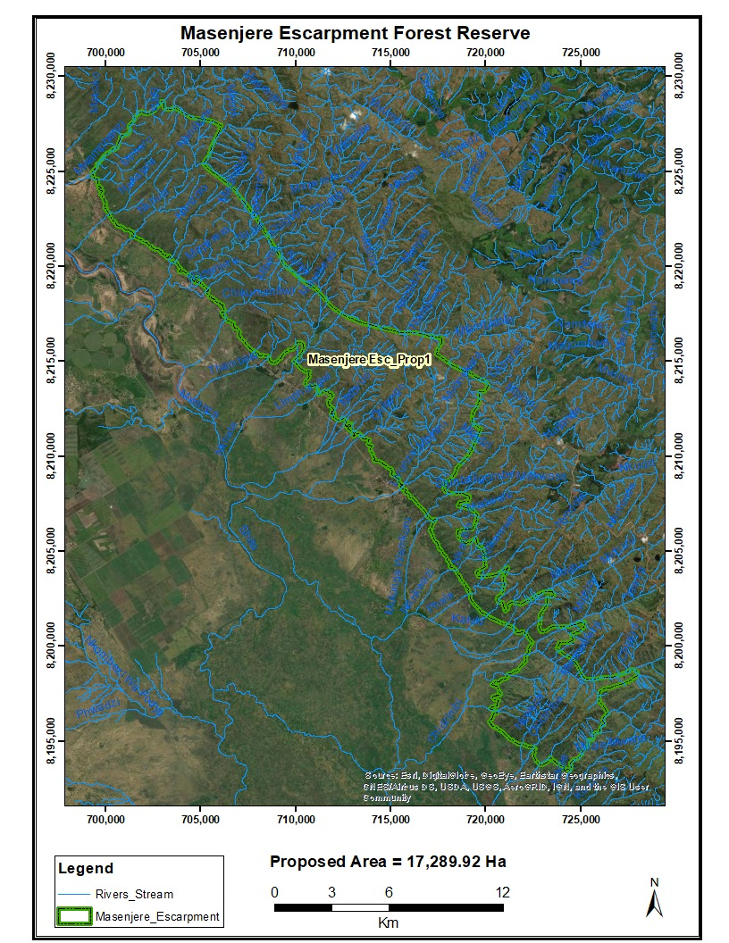

Fig. 1 Map of Masenjere Escarpment

3.1.2 Strategic Issues
- Lack of regulated access to village forest areas (VFAs)
- Uncontrolled bush fires
- Non-functional local institutions such as Village Natural resources Committees (VNRMCs)
- Unsustainable exploitation of forest resources

- Overdependence on forest resources as safety nets or coping mechanism
- Unreliable water supply

3.1.3 Proposed Activities
- Natural regeneration in the escarpment
- Fire prevention and protection
- Strengthening governance structures
- Enhancement of IGAs
- Riparian planting with tree seedlings and or bamboo culms
- Homestead planting of multi-purpose agroforestry tree species
- Soil and water conservation structures
  - Storm water drains
  - Swales
  - Gabions

3.2 Masenjere Forest Reserve – Nsanje district

3.2.1 Introduction of Masenjere Forest Reserve
  - It is situated in Nsanje district as part of Msenjere escarpment but with a protected area status hence a forest reserve
  - Gazetted in 1929
  - Originally created with an objective water catchment and preserve unique vegetation
  - No perennial rivers

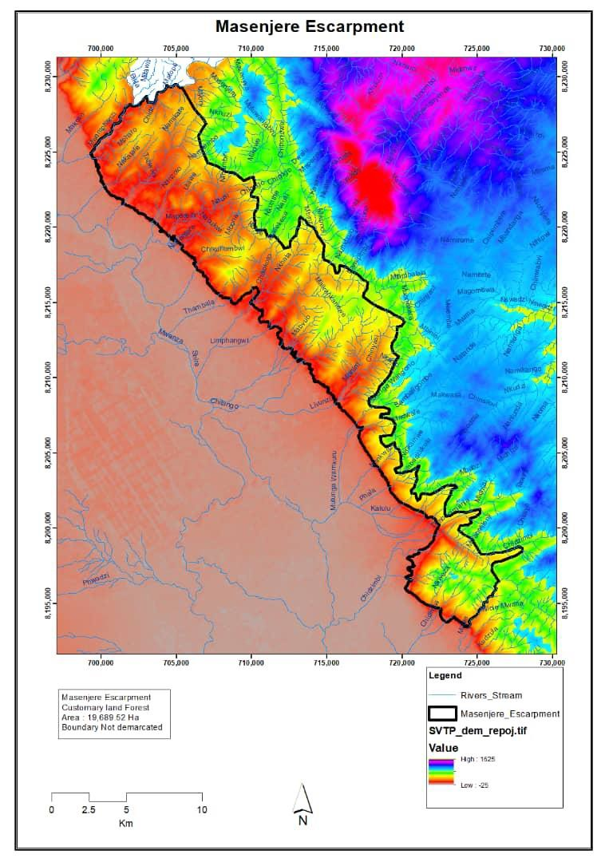

Fig. 2 Map of Masenjere as a continuum of Masenjere Escarpment

3.2.2 Proposed Activities
- Natural regeneration
- Riverine planting
- Bamboo growing

- Water and soil conservation structures

3.3 Thyolo Mountain Forest Reserve – Thyolo district

3.3.1 Introduction of Thyolo Mountain Forest Reserve

  - 1621 ha in area
  - Completely devoid of tree vegetation
  - Turned into crop land
  - Important water catchment
  - Three major rivers emanate from it including Nsuwazi, Maperela, Nkhate
    - Only source of water for the town
    - Tea estates also depend on it
    - District suffers from acute water shortage due to its complete deforestation & degradation
  - Gazetted for water catchment and unique bird species the Thyolo Alethe
  - The district does not have any other source of fuel

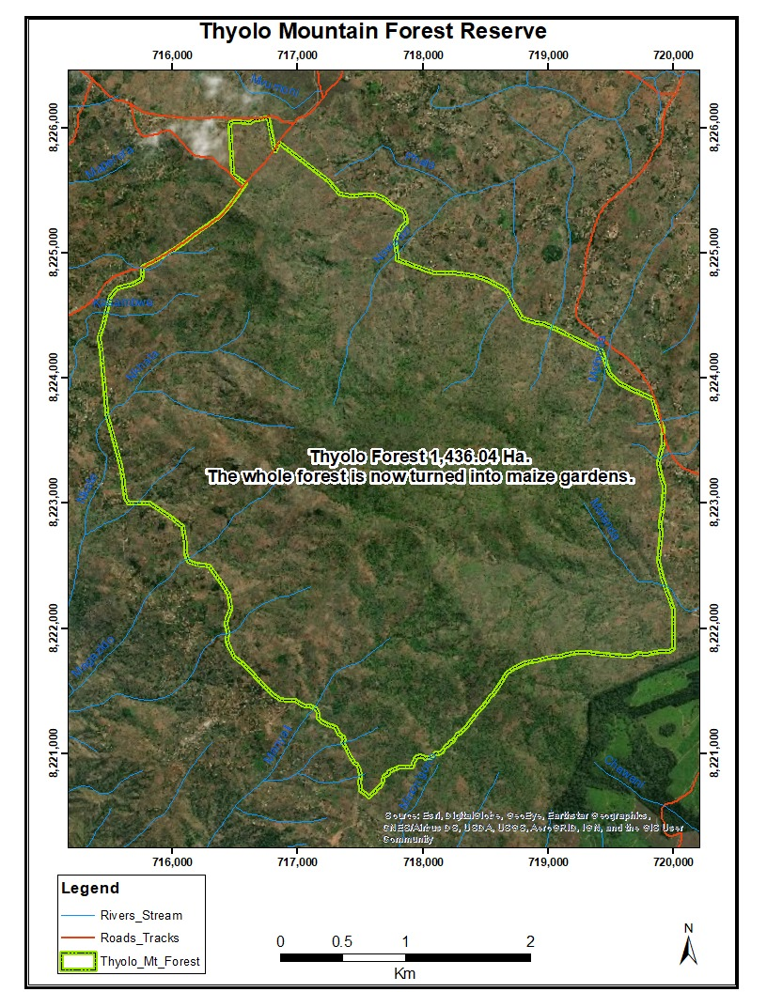

Fig. 3 Map of Thyolo Mountain Forest Reserve

3.3.2 wood & pole Proposed Activities
- Riverine planting
- Bamboo growing
- Homestead planting
- Community woodlots
- Tea growing to sell at surrounding tea estates?
- Engage parliamentary committee on environment and local institutions to assist with local community buy-in

3.3.3 Potentials systems for addressing Thyolo Mountain
- Payment for ecosystem services (PES)
- REDD+ model (result-based payment) on annuity or monthly basis that can support peoples’ livelihoods. Adopt the SAPPI model in RSA using the L View to monitor tree/seedling survival
- Small scale concessions

- Incentive system for incorporating tree-agricultural crops combination

3.3.4 Opportunities/Strengths
- Some communities willing to regrow trees in the reserve
- Initial fertility of the soils in the reserve has gone down, hence no higher crop productivity
- Other farmers growing tree crops like tea
- Water shortage in the district is severe making communities realize the importance of trees
- Shortage of construction materials
- Surrounding estates distributing tree seedlings to communities
- The threat are compelling reasons for increasing forest cover

3.4 Thambani Forest Reserve

3.4.1 Introduction of Thambani Forest Reserve

  - Located in Mwanza district
  - Source of current woodfuel for Blantyre city
  - Deforestation and forest degradation is increasing due also to proximity to Zobwe town, in Mozambique and Mwanza and Blantyre peri-urban centers
  - However, forest cover is relatively intact

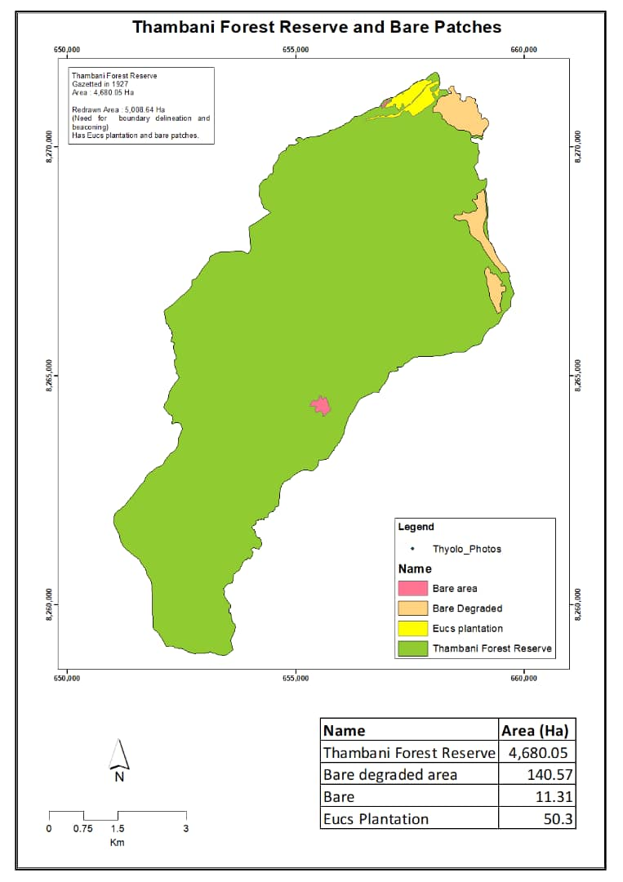

Fig. 4 Thambani Forest Reserve

3.4.2 Proposed Activities:
- Natural regeneration
- Forest-based enterprises (FBEs) – beetle (nkhunguni, sesenya), bee-keeping in value addition like packaging, processing etc.
- Bamboo growing
- Natural regeneration and revegetation
- Capacity building – revamping local institutions such as VNRMCs
Empowerment of local institutions due to decentralization/devolution processes
- Con-management of protected area of the forest reserve
- Private Public Partnership (PPP) of the plantation side of the area
- Riverine planting
- Bamboo growing
- Eco-tourism to historical sites

4.0 STRUCTURE OF THE FOREST MANAGEMENT PLAN

4.1 Introduction
  - Description of area
  - Legal status and ownership
  - Importance of area
  - Physiological and ecological status
    - Dominant tree species and tree stocking
    - Qualitative information Forest Management Plan Development
  - Goals

  - Objectives
  - Activities to achieve the management objectives
  - Activities prohibited

4.2 Activity Schedule and Implementation Structure
- Implementation structure
- Communication
  - Guiding principles for design and implementation of the FMP Monitoring and Evaluation Plan

4.3 Stakeholders, Roles and Responsibilities

5.0 APPENDICES
Table 1. below shows a list officers and the expertise that they have for the development of Forest Management Plan.

Table 1. Expertise for FMP

NAME | INSTITUTION | EXPERTISE/EXPERIENCE | EXPERIENCE?

6.0. WHY WE THINK THE TASK OF FMP IS BETTER DONE BY DEPARTMENT OF FORESTRY STAFF NOT CONSULTANT
  - Development of FMPs is the lead responsibility of central government under the decentralization of forest management responsibilities implementing the Local Government Act 1998 and the National Forestry Program 2001
  - The DoF is both the lead agency and implementer best suited for the task and well versed when it comes to standards and guidelines
  - Way of enhancing forest extension service provision & delivery across the sector but also ensure that the beneficiaries of the service receive quality support and direction as such are empowered in the manner intended by the policy and legal framework
  - Ensure that participatory forestry processes that comprise elements considered best practice are delivered
  - Ownership of the process within the DoF unlike if done by consultants
  - FMPs needed both to guide field practice and set benchmarks for service delivery to assist in monitoring of the implementation of the policy and legal framework that apply to natural resource management in the country
  - It is hoped that the adoption of the FMP will address many of the gaps in terms of promoting practical actions or achieving sustainable forestry in support of rural livelihoods

